**McDonalds Database Market Segmentation**

**ANSHIKA SINGHAL**

Market segmentation is a process that consists of sectioning the target market into smaller groups that share similar characteristics, such as age, income, personality traits, behaviour, interests, needs, or location. Segmentation allows brands to create strategies for different types of consumers, depending on how they perceive the overall value of certain products and services. In this way, they can introduce a more personalized message with the certainty that it will be received successfully.

**. DECIDING (NOT) TO SEGMENT:**

Market segmentation is a long term process. It requires willingness and ability of organisation to make profitable changes. Potentially required changes include the development of new products, the modification of existing products, changes in pricing and distribution channels used to sell the product, as well as all communications with the market.

Market Segmentation when applied in any organisation requires high capital. It is a costlier process. It needs a big Organisation so as to handle the part of segmentation process. Segment can also be denied if there is lack of perfect leadership. Senior management can also prevent market segmentation to be successfully implemented by not making enough resources available, either for the initial market segmentation analysis itself, or for the long-term implementation of a market segmentation strategy.

Organisation culture can also affect the part of segmentation. Bad communication, lack of creativity, unsound ideas, unwillingness to make changes, politics in office and much more are the most basic and strong reasons to the failure of market segmentation in a particular work field. Lack of training is one more cause. No proper training to the office workers can result into the poor quality outcome. Lack of qualified data manager and analyst in organisation can also represent major hurdles.

Instead of all these, there are many objective restrictions also. Like financial resources. A company with limited resources needs to pick only the best opportunities to pursue. Segmentation is an investment. Splitting your market into groups means you'll have to do some things, for instance, marketing campaigns, multiple times in different ways. This can be more time-consuming and expensive than running a campaign aimed at a single market. There is no way to avoid this challenge.

. **SPECIFYING THE IDEAL TARGET SEGMENT:**

For a market segmentation analysis to produce results that are useful to an organisation, user input needs to be taken in care. User should be an active participator in all stages of market segmentation. There are two criteria defined for specifying the ideal target segment.

1. Knock-out criteria
2. Attractiveness criteria
   1. KNOCK-OUT CRITERIA:

'Knock-out criteria' are the non-negotiable features a segment must have to make it worthwhile – for example, it must be big enough, match your strengths and you must be able to reach the members in some way. ' It states some condition for segment.

1. The segment must be homogeneous
2. The segment must be distinct
3. The segment must be large enough
4. The segment must be matching the strengths of the organisation
5. Members of the segment must be identifiable
6. The segment must be reachable

Knock-out criteria must be understood by senior management, the segmentation team, and the advisory committee.

* 1. ATTRACTIVENESS CRITERIA:

 A segment becomes attractive when the product in question seems new to the customers and has plenty of room to expand. In business, a segment attractiveness refers to the appeal of a market segment to a business and its potential of providing long-term profit to the same. Segments are not assessed as

either complying or not complying with attractiveness criteria. Rather, each market segment is rated; it can be attractive with respect to a specific

criterion.

* 1. IMPLEMENTING A STRUCTURED PROCESS:

Define the market: Identify the market you are interested in segmenting. This may involve defining the product category, geographic region, or other factors that define the market.

Identify potential segmenting variables: Brainstorm a list of potential variables that could be used to segment the market. These may include demographic, psychographic, behavioural, or other factors that are relevant to the market.

Refine the list: Review the list of potential variables and select the ones that are most relevant and actionable. Eliminate any that are redundant, difficult to measure, or unlikely to differentiate customer needs or behaviors.

Collect data: Gather data on the selected variables using surveys, interviews, or other research methods. Ensure that the data is representative of the market and that there is enough data to support analysis and segmentation.

Analyse the data: Use statistical methods such as clustering or factor analysis to identify patterns in the data and group customers into segments based on their similarities and differences.

Validate the segments: Evaluate the segments to ensure that they are meaningful, actionable, and useful. This may involve testing the segments using external data or conducting additional research to validate the findings.

Develop segment profiles: Create profiles of each segment that describe their needs, behaviours, attitudes, and other relevant characteristics. Use these profiles to tailor marketing messages and strategies to each segment.

Implement and monitor: Develop marketing strategies and tactics for each segment and track performance over time. Adjust the strategies as needed based on feedback and results.

**. COLLECTING DATA:**

Segmentation variables refer to the factor’s marketers use to categorize their audience into different groups. The 4 main types of segmentation variables include demographic, geographic, psychographic, and behavioural traits.

In order to create an effective marketing strategy, it is important to segment your audience. Not only does segmentation ensure your target audience receives the most relevant content, but it also increases the likelihood of success.

1. GEOGRAPHIC SEGMENTATION:

Geographic segmentation tells you where your audience is located. Like demographic segmentation, categorizing your contacts according to geographic location is straightforward.

Here are a few geographic variables you can use to divide your audience:

#Location (Includes factors such as zip code, city, state, and country)

#Culture

#Time zone

#Language

#Climate

#Population density

1. DEMOGRAPHIC SEGMENTATION:

Demographic segmentation enables you to understand who your target audience is, which is critical for building customer personas. A customer persona is essentially a profile used to represent your target market according to the data obtained from segmentation. Segmenting based on personas can provide 90% of companies with better knowledge about their audience.

This type of segmentation is also an excellent place to start if you want to understand your audience and if you’re just learning the ropes of segmentation since it’s easy to use.

Demographic segmentation variables include:

#Age

#Gender

#Religion

#Income level

#Ethnicity

#Size of household

#Occupation

#Education

#Marital status

1. PSYCOGRAPHIC SEGMENTATION:

Psychographic segmentation enables businesses to segment their contacts based on psychological traits that influence shopping. Variables include:

#Attitudes

#Values

#Social status

#Lifestyle

#Personality

#Interests

#Opinions

While it can be difficult to segment audiences using this approach, doing so results in highly effective marketing campaigns. This is because psychographic segmentation provides insight into why consumers buy certain products.

1. BEHAVIOURAL SEGMENTATION:

Behavioural segmentation refers to a type of market segmentation in which you group your audience based on consumer behavior, allowing you to see how customers interact with your business. With behavioral segmentation, you can see what your contacts are doing on your website, determine which ones engage with your brand the most, and identify patterns to plan ahead.

Variables of behavioural segmentation include:

#Purchasing behaviour

#Stage in the customer journey

#Occasion or timing

#Usage behaviour

#Benefits sought

#Customer loyalty

#Customer satisfaction

#Engagement

2.2 DATA SURVEY:

Surveys are a common method of data collection for market segmentation. They can be conducted online, by mail, or in person. Surveys can provide information on customer demographics, purchasing habits, and preferences.

2.2.1 Choice of Variables:

Choice of variable should be done carefully. Variables should not be noisy. Unnecessary variables should be avoided, including unnecessary variables will make the work process tedious.

2.2.2 Response Variables:

It is important to choose the right type of response option for each question in a survey, as this can impact the quality and reliability of the data collected. When collecting data for market segmentation through surveys, it is important to carefully consider the response options provided to respondents. The response options should be clear, unambiguous, and cover the full range of potential responses.

2.2.3 Response Styles:

Response style in data collection by survey refers to the way respondents answer questions in a survey. It includes various types of response styles such as acquiescence bias, extreme response style, social desirability bias, and midpoint response style. These response styles can affect the validity and reliability of survey results, so it is important to be aware of them and take steps to mitigate their impact on the data.

2.2.4 Sample Size:

Many statistical analyses are accompanied by sample size recommendations. Not so market segmentation analysis.

2.3 DATA FROM INTERNAL SOURCES:

Many organisations has the access to internal source data of the company. Typical examples are scanner data available to grocery stores, booking data available through airline loyalty programs, and online purchase data.

2.4 DATA FROM EXPERIMENTAL STUDIES:

Experimental studies in organizations are research designs that involve manipulating one or more independent variables to observe their effect on one or more dependent variables. Data collected from experimental studies in organizations can provide valuable insights into the causal relationships between variables and help organizations make informed decisions about their practices and policies.

. **DESCRIBING SEGMENTS:**

Describing a segment in market segmentation involves identifying and characterizing a group of consumers who share similar characteristics or behaviours that are relevant to the product or service being marketed. This can be done through a combination of demographic, psychographic, behavioural, and geographic data.

3.1 *DEVELOPING A COMPLETE PICTURE OF MARKET SEGMENT:*

Descriptive segment is similar to profiling step. In this, market segments are described with visuals and more information. Describing segment in itself is a long-term process. It helps in telling the potential of the selected segments by visuals or statistics. It makes use of additional information like age, gender, behaviour etc. By making use of this additional information, it gives out the relation among the segments.

3.2 *USING VISUALIZATIONS TO DESCRIBE MARKET SEGMENTS:*

Visualization can be a powerful tool to describe market segments. Some examples of visualization techniques that can be used include bar chart, pie chart, scatter plots, heat maps and word clouds etc. There are several advantages of using graphical statistics for market segmentation, such as Easily understandable , quick view, visual appeal etc.

3.2.1 NOMINAL AND ORDINAL DESCRIPTOR VARIABLES:

In statistics and data analysis, variables can be classified as nominal or ordinal depending on the type of data they represent.

Nominal variables are variables that represent categorical data with no natural ordering or hierarchy among the categories. Examples of nominal variables include gender, race, religion, and country of origin. Nominal variables are often represented using frequencies or percentages in tabular or graphical displays.

Ordinal variables, on the other hand, are variables that represent categorical data with a natural ordering or hierarchy among the categories. Examples of ordinal variables include income level, education level, and level of agreement on a Likert scale. Ordinal variables are often represented using frequency tables, bar charts, and pie charts.

Mosaic plots can also visualise tables containing more than two descriptor variables and integrate elements of inferential statistics. This helps with interpretation. Colours of cells can highlight where observed frequencies are different from expected frequencies under the assumption that the variables are independent.

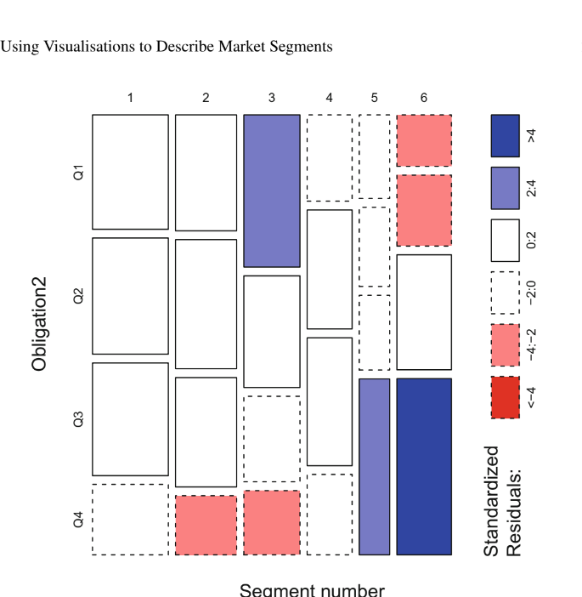

3.2.2 METRIC DESCRIPTOR VARIABLE:

A metric descriptor variable is a type of variable that has a numerical value that is meaningful and can be compared and measured on a quantitative scale. Examples of metric descriptor variables include age, weight, height, income, and number of products purchased.

Metric variables can be further classified into two types:

1. Continuous: A continuous variable can take any value within a certain range. For example, age is a continuous variable as it can take any value between 0 and infinity.
2. Discrete: A discrete variable can only take specific values. For example, the number of children in a family is a discrete variable as it can only take integer values (1, 2, 3, etc.).

We can use a modified version of the segment level stability across solutions (SLSA) plot to trace the value of a metric descriptor variable over a series of market segmentation solutions.

3.3 *TESTING FOR SEGMENT DIFFERENCES IN DESCRIPTOR VARIABLES:*

Once the market segments have been identified and described based on the descriptor variables, it is important to test whether there are any significant differences between these segments in terms of these variables. This can be done using various statistical tests such as analysis of variance (ANOVA), t-tests, and chi-square tests.

For nominal and ordinal descriptor variables, chi-square tests can be used to test for significant differences between segments. This test compares the observed frequencies in each segment with the expected frequencies, assuming that there is no difference between segments.

For metric descriptor variables, ANOVA and t-tests can be used to test for significant differences between segments. ANOVA tests for overall differences between the means of multiple groups, while t-tests compare the means of two groups. It is important to note that ANOVA assumes equal variances between groups, while t-tests do not.

It is also possible to use graphical methods to compare the distribution of descriptor variables across segments. Box plots, histograms, and density plots can be used to visualize the distribution of metric variables, while bar charts and mosaic plots can be used to visualize the distribution of nominal and ordinal variables.

3.4 *PREDICTING SEGMENTS FROM DESCRIPTOR VARIABLES:*

We can use regression model for the predicting segments. We can use this model for categorical dependent variable, descriptor, and independent variable. It is essential to keep in mind that the model's accuracy and usefulness depend on the quality of the data, the choice of variables, and the selected regression algorithm. Therefore, it is crucial to ensure that the data is of high quality and that the chosen variables and algorithms are appropriate for the problem at hand. In these models the dependent variable follows either a binary or a multinomial distribution, and the link function is the logit function.

3.4.1 BINARY LOGISTIC REGRESSION:

Binary logistic regression is a statistical method used to model the relationship between a binary dependent variable (also known as the outcome variable or response variable) and one or more independent variables (also known as predictor variables or explanatory variables). It is a type of generalized linear model that is commonly used in cases where the dependent variable is dichotomous, meaning it can only take on two possible values (e.g., success/failure, yes/no, etc.). In binary logistic regression, the regression coefficients indicate how the linear predictor changes. The changes in the linear predictor correspond to changes in the log odds of success.

The goal of binary logistic regression is to estimate the probability of an event occurring based on one or more predictor variables. The model estimates the log odds of the event occurring (i.e., the logit), which is then transformed into a probability using the logistic function. The logistic function is an S-shaped curve that ranges from 0 to 1 and represents the probability of the event occurring as a function of the predictor variables.

3.4.2 MULTINOMIAL LOGISTIC REGRESSION:

Multinomial logistic regression is a type of regression analysis used to predict categorical outcomes with more than two levels. It is similar to binary logistic regression, but instead of predicting a binary outcome (such as whether someone will buy a product or not), it predicts a categorical outcome with more than two possible outcomes (such as which brand of product a customer is most likely to buy).

In multinomial logistic regression, the dependent variable is a nominal variable with three or more categories, and the independent variables can be nominal, ordinal, or metric. The model estimates the probability of each category of the dependent variable, given the values of the independent variables.

The multinomial logistic regression model is estimated using maximum likelihood estimation, and the goodness of fit of the model can be assessed using various measures, such as the likelihood ratio test, the McFadden's pseudo R-squared, and the Akaike Information Criterion (AIC) or Bayesian Information Criterion (BIC).

3.4.3 TREE BASED METHODS:

Tree-based methods are another way to predict segments based on descriptor variables. These methods recursively partition the data into smaller and smaller subsets until the resulting subsets are relatively homogeneous with respect to the target variable (in this case, the market segment). The tree approach uses a stepwise procedure to fit the model. At each step, consumers are split into groups based on one independent variable. The aim of the split is for the resulting groups to be as pure as possible with respect to the dependent variable. This means that consumers in the resulting groups have similar values for the dependent variable.